[COMPUTER VISION AND PATTERN RECOGNITION [C]](https://portal.aiub.edu/Student/Section?q=ZGNZ55p%2FrDvdhSZrbcFYvA%3D%3D)

ASSIGNMENT-2 [FINAL TERM]

Student Name: Shahriar Hossain Rafi

Student ID: 20-42528-1

Submitted to: DR. DEBAJYOTI KARMAKER

1. **Import the needed libraries.**

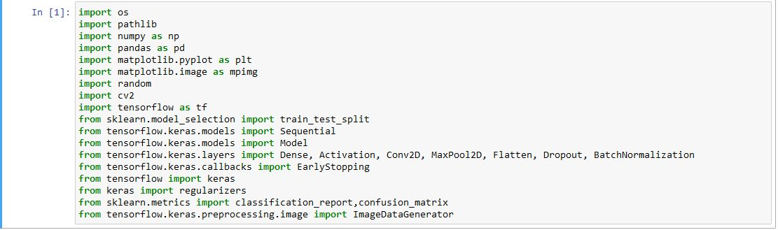

1. **Augmenting the dataset**

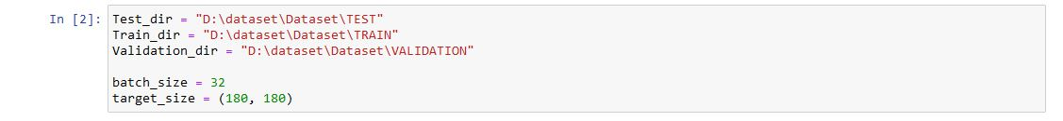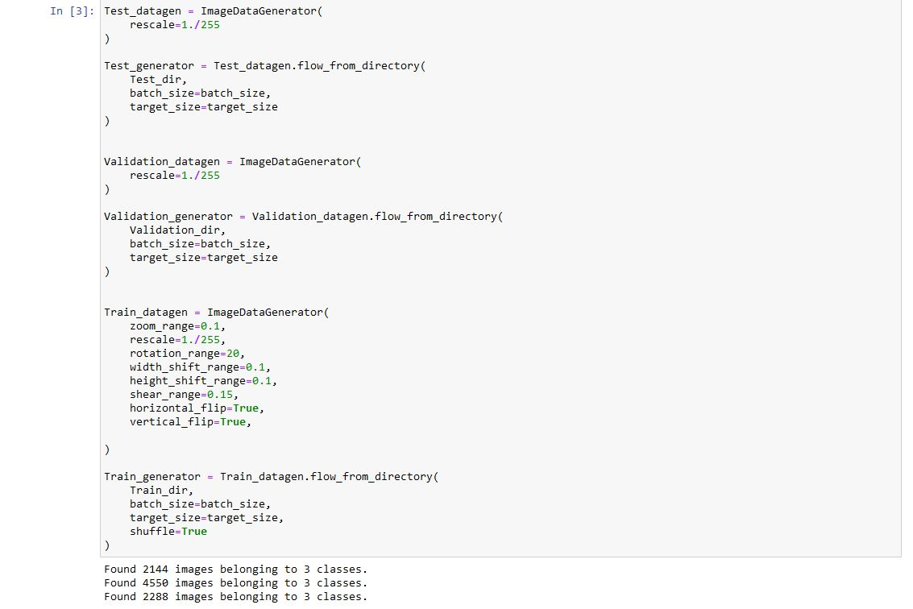

1. **Displaying the Dataset categorized.**

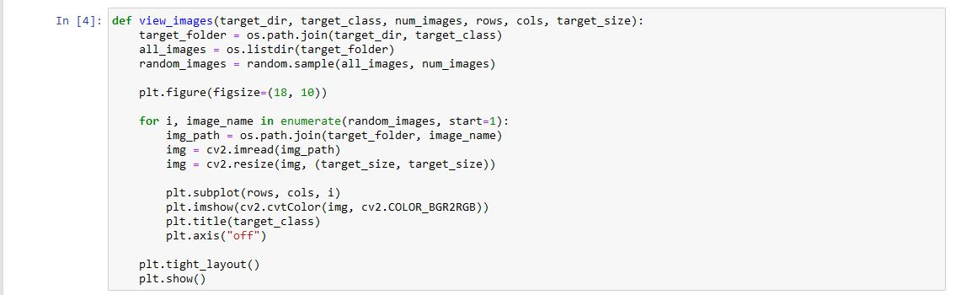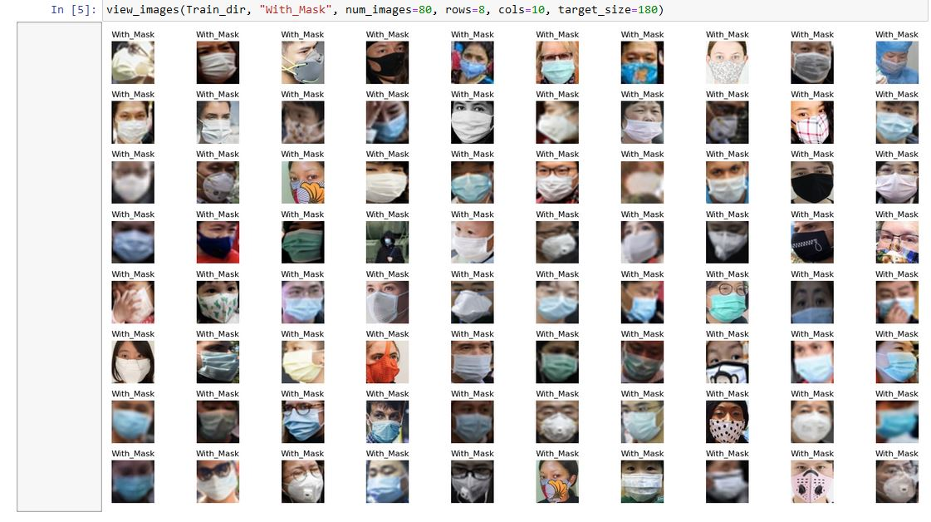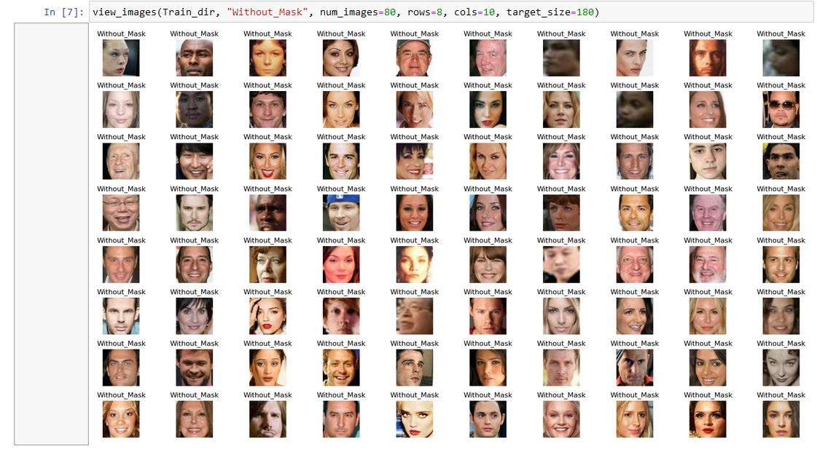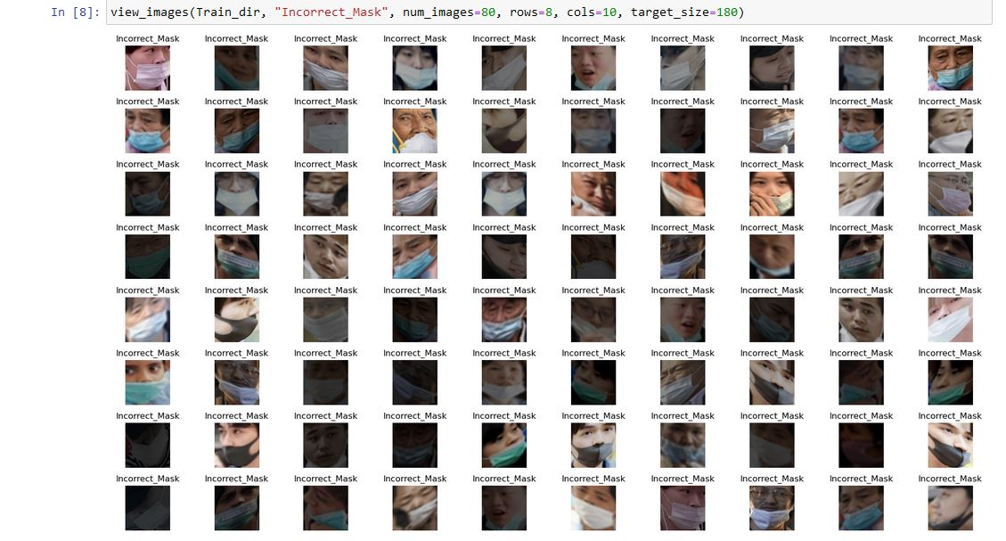

1. **Labeling the data for Train, Test and Validation and getting their shapes.**

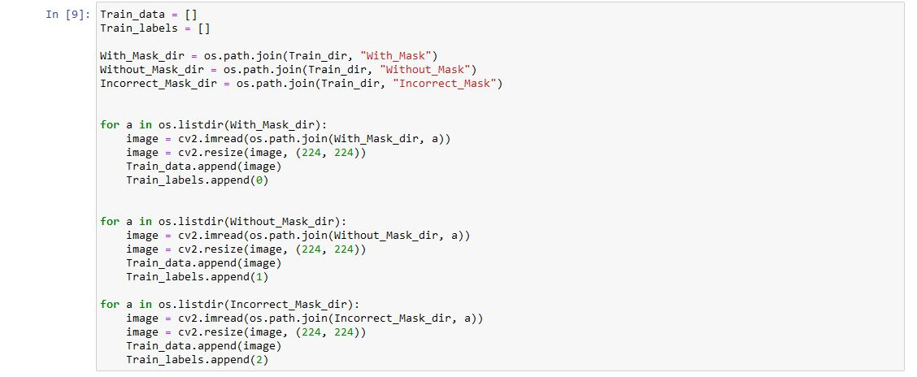

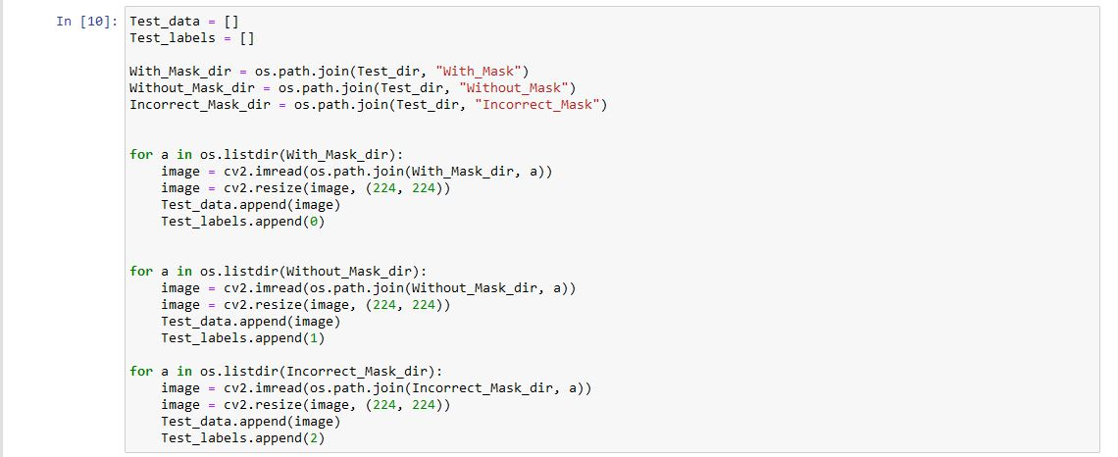

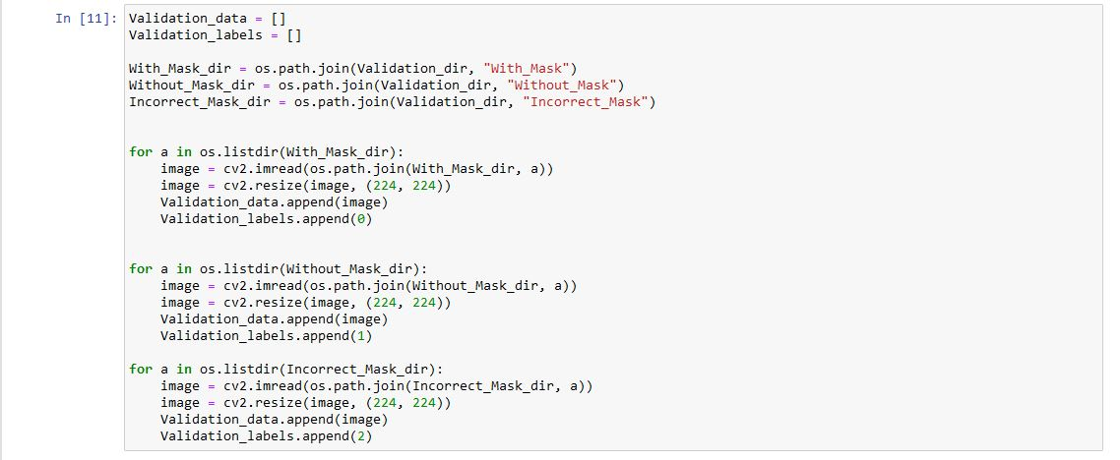

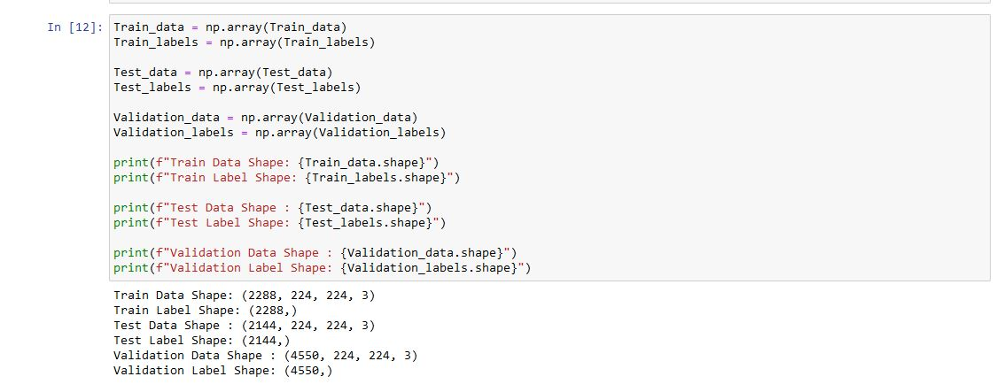

1. **Building our model**

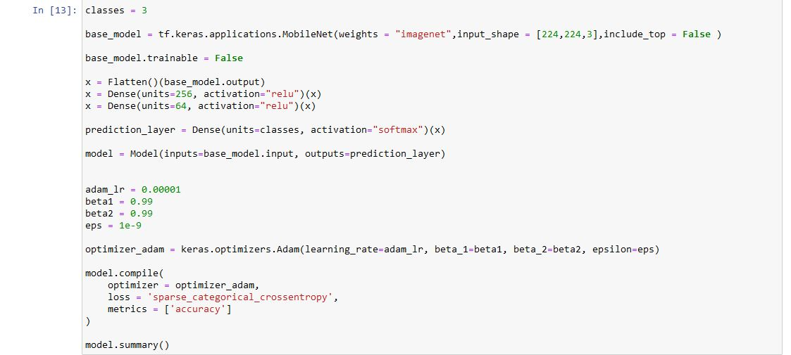

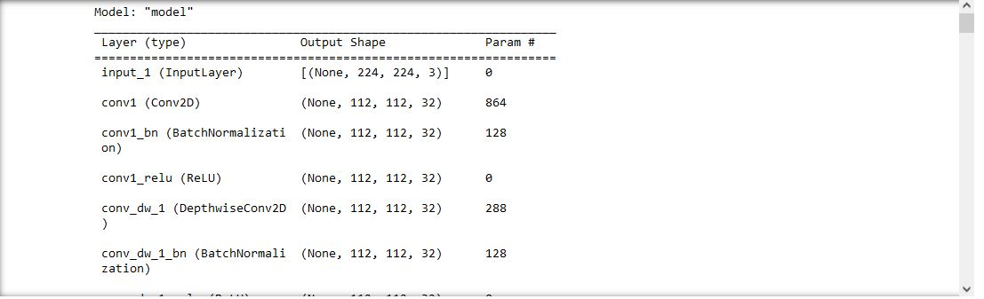

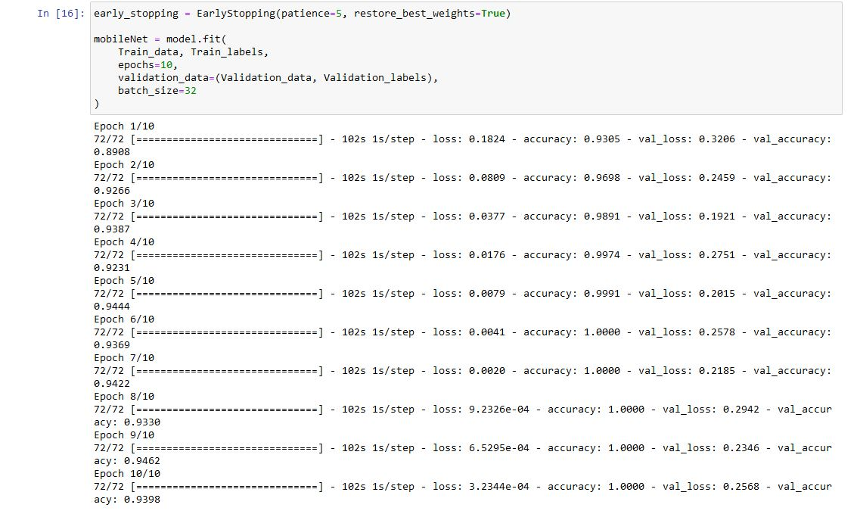

1. **Plotting the Result**

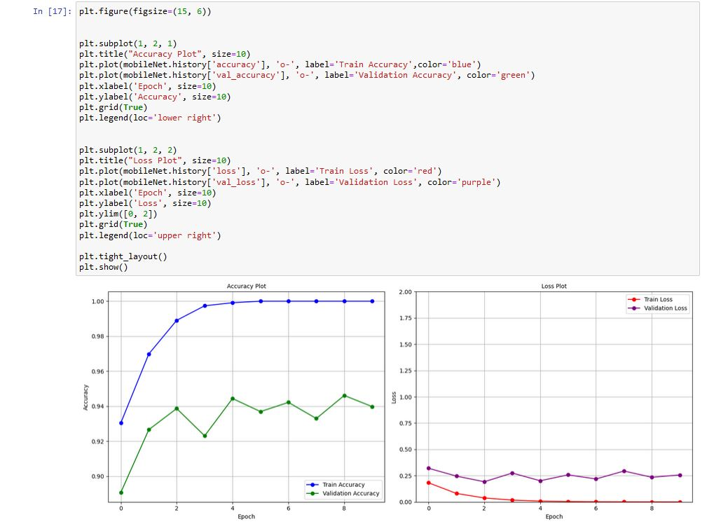

1. **Making the Prediction**

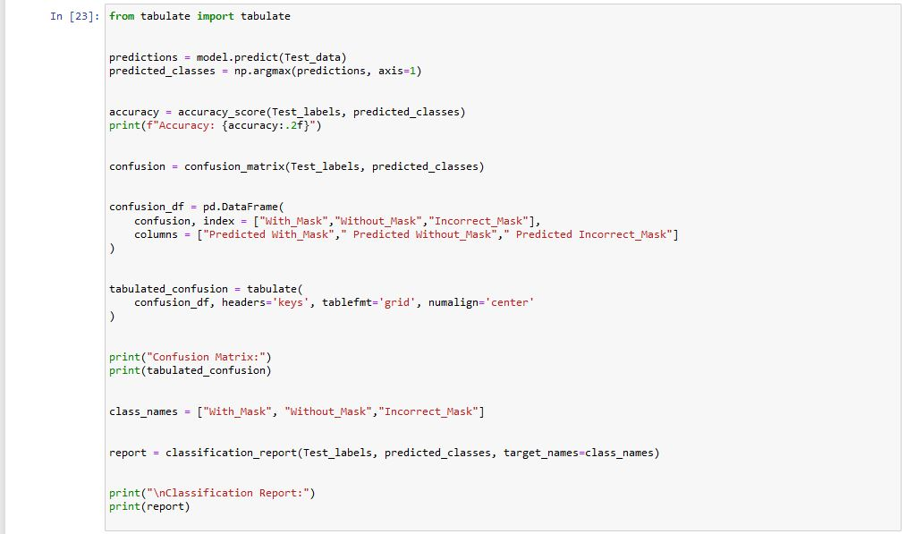

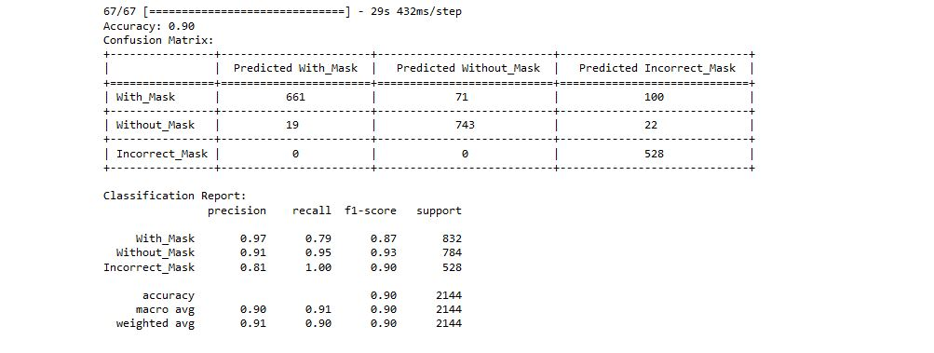

**Discussion:**

The model was built to recognize images with face mask, without mask and incorrect mask.

The classification report suggests that the accuracy achieved is 90%, indicating that the model is effective at correctly classifying images. The confusion matrix provides insight into the distribution of predictions across the different classes. Notably, the model seems to perform well on the "Without_Mask" class, with high precision and recall. However, it exhibits lower precision for the "Incorrect_Mask" class. The report also presents detailed metrics such as precision, recall, and F1-score for each class, along with overall accuracy. The model's strong performance on most metrics indicates its capability to distinguish between classes, while areas with lower scores highlight opportunities for refinement. The model exemplifies an effective approach to building and training an image classification model, which can be further refined and extended for specific applications.